PyMoIP – Gateway

Operation :

* Accept users coming from Telnet or WebSocket ports
* Accept admin coming from Telnet display/admin port
* Route user keypress to the Videotext server and Videotext server’s data back to the user (no echoing in PyMoIP Gateway as most servers will do it)
* Manage gateway command session for redirections (call remote Videotext server, inform Teletel module about user details [user @IP, user session number])
* Many users may reach simultaneously the gateway from Telnet or WebSockets
* Many Videotext servers [internal instances or remote/foreign servers] may be simultaneously contacted

PyMoIP  
Gateway

Will manage most administrative aspects of user sessions. It’s the only part of PyMoIP that needs to be exposed to outside world.

- Logging  
- Timeouts  
- Telnet ⬄ WS translation  
- Negociation with Teletel server  
- Redirection to other servers  
- Ban rogue @IPs (port scanners)  
- Monitor ‘Local/Line’ key (to cancel redirection)

WebSocket incoming user session  
Default : port 9001 on IPv4 @IP

Telnet incoming admin session  
Default : port 8999 on IPv4 @IP

Gateway command session to default Videotext server  
Default : port 8764 on 127.0.0.1

Gateway user session to default WS Videotext server  
Default : port 8765 on 127.0.0.1

Telnet incoming user session  
Default : port 9000 on IPv4 @IP

Default Videotext server  
(Should be Teletel to allow redirections)

Gateway user session redirected to a WS Videotext server  
No default : port or @IP

User selected Videotext server [local or remote]

Init step:

A command session is openned with default videotext server and maintained as much as possible (retry every 5 seconds if it fails).

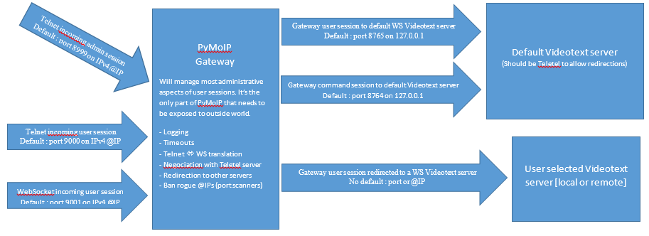

Open a session with default Videotext server

User arrival :

On user arrival [Telnet or WS], the gateway will :

* Check for banned @IP and drop banned @IP session.
* Send a welcome line
* Establish a session to default Videotext server WS.
* Pass each received character from the user to the Videotext server.
* Pass each received character from the Videotext server to the user.
* Monitor user session and drop Videotext server session when user leaves.

Notes :

* When coming from Telnet :
  + IAC protocol negotiation supported to disable local TN echo
  + The first 144 characters received from the user in the first second of the session are dropped to allow smooth operation of legacy iTimtel emulator.
* Monitor the first END-ROM coming from the server and reply with real user’s @IP [needed for display in Videotext pages] and Gateway session number [needed for redirection]. Reply special ROM code (xFF xFF xFF) before valid data.
* Default Videotext server is supposed to act as a Teletel PAVI simulator and use the “module_teletel.py” module.
  + Activate (virtual) billing display once [INDEX] key is pressed
  + Provide an input field to select expected Videotext server keyword
  + Lookup into an externally centralized reference to obtain necessary parameters from the keyword after [SEND] key is pressed
  + [TBD] select custom server with all possible parameters (using extended data field with [NEXT] key)
  + Initiate the redirection process of the gateway
  + Features not implemented in the gateway
    - Intermediate buffering [IE : all characters are passed on the fly, not waiting buffer full or function key]
    - No echo [to be done by the Videotext server]
    - No PCE
    - No monitoring on Minitel status



User in communication with default Videotext server (PAVI/Teletel simulation)

User redirection :

On redirection negociation completed :

* Establish a session to selected Videotext server [WS only, Telnet TDB].
* Pass each received character from the user to the redirected Videotext server.
* Pass each received character from the both Videotext server to the user.
* Monitor user session and drop both Videotext server session when user leaves.
* Monitor user keys for [LOCAL/LINE]. If received, drop the session with the redirected Videotext server and revert to un-redirected state.



User in communication with redirected Videotext server

User in communication with default Videotext server (billing simulation)